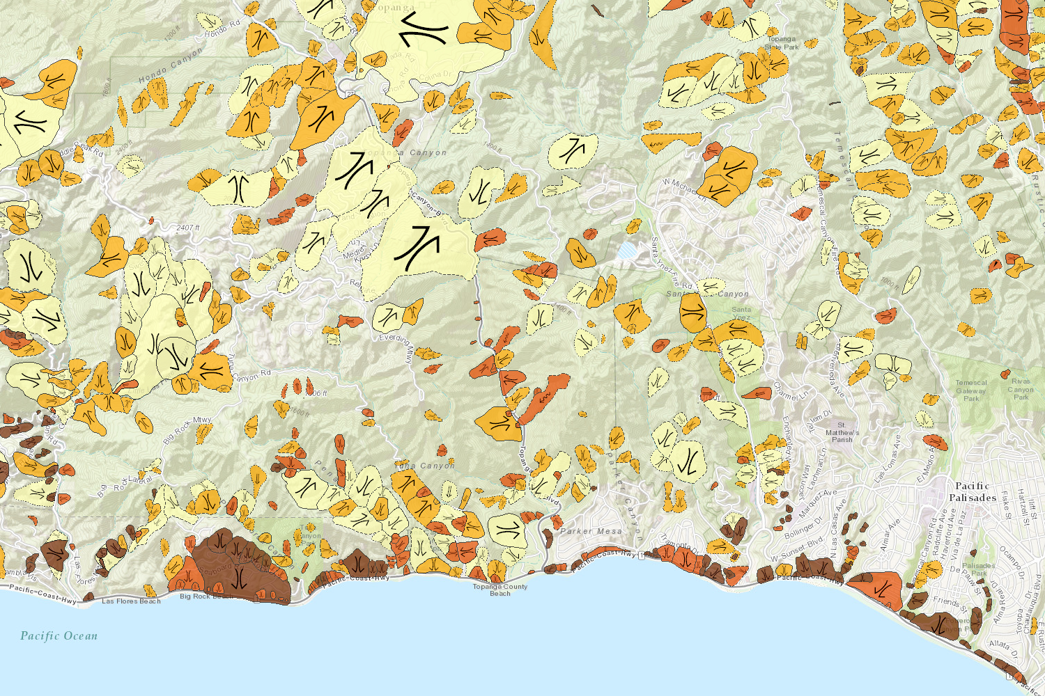

https://maps.conservation.ca.gov/geology/

Department of Conservation
Grade 4 Lesson Sequence: Landslides

California Next Generation Science Standards:

4-ESS2-1. Make observations and/or measurements to provide evidence of the effects of weathering or the rate of erosion by water, ice, wind, or vegetation. [Clarification Statement: Examples of variables to test could include angle of slope in the downhill movement of water, amount of vegetation, speed of wind, relative rate of deposition, cycles of freezing and thawing of water, cycles of heating and cooling, and volume of water flow.] [Assessment Boundary: Assessment is limited to a single form of weathering or erosion.]

4-ESS2-2. Analyze and interpret data from maps to describe patterns of Earth’s features. (topography) [Clarification Statement: Maps can include topographic maps of Earth’s land and ocean floor, as well as maps of the locations of mountains, continental boundaries, volcanoes, and earthquakes.]

California Environmental Principles and Concepts:

Principle I—People Depend on Natural Systems. The continuation and health of individual human lives and of human communities and societies depend on the health of the natural systems that provide essential goods and ecosystem services.

Principle II—People Influence Natural Systems. The long-term functioning and health of terrestrial, freshwater, coastal and marine ecosystems are influenced by their relationships with human society.

Principle III—Natural Systems Change in Ways that People Benefit from and Can Influence. Natural systems proceed through cycles that humans depend upon, benefit from and can alter.

Principle IV—There are no Permanent or Impermeable Boundaries that Prevent Matter from Flowing Between Systems. The exchange of matter between natural systems and human societies affects the long-term functioning of both.

Principle V—Decisions Affecting Resources and Natural Systems are Complex and Involve Many Factors. Decisions affecting resources and natural systems are based on a wide range of considerations and decision-making processes.

Anchoring Phenomenon for lesson sequence: Landslides caused by weather are a rapid event that causes changes to the Earth surface.

Lesson 1 – Modeling Landslides

Learning Objective: Students will be able to identify what happens during a landslide and some of the characteristics of a landslide. They will be able to explain what factors contribute to landslides (heavy rain, fires, human activity, runoff, etc.)

Investigative Phenomena: The landscape can move quickly under specific conditions.

Guiding Question: What conditions must exist for a landslide to occur?

Lesson Implementation Timeframe: 1 (50-60 minute) class period

Classroom Resources and Materials:
- Landslides Lesson 1 PowerPoint
- Student Handout: L1 H1 Landslides 101 Beta
- Student Handout: L1 H2 Landslide Diagram Beta

Procedures:

Engage

- Display slide 1. Welcome students! Tell students that they will be starting a new lesson about landslides. Ask students, “What do you know about landslides?” to assess prior knowledge. In grade 2, students are introduced to landslides, earthquakes, weathering and other evidence of natural events that can occur quickly or slowly to change landscapes (2-ESS1-1). Recognize all student answers and let them know that they may know a lot about landslides, but in this lesson sequence they will deepen their understanding of the causes and effects.

- Display slide 2. Introduce students to the guiding question: “How can people prepare for the effects of the changing landscape on property?” and tell them that this will be the question that will be re-visited throughout the sequence of lessons. Display this question on a bulletin board and create space for students to add ideas or questions that connect to the guiding question.

- Display slide 3. Introduce the lesson by sharing with the students that they will be learning about landslides and what causes them. Make sure to preface this lesson by keeping students’ emotions in mind. There were no houses destroyed or people killed in the landslide example that will be used in this lesson sequence, the students may know of other landslides that have caused these things to occur. There are also images of these in the PowerPoint and references made in the lesson to other deadly landslides (Montecito and La Conchita). Show them the short news clip about the Mud Creek Landslide on May 20th, 2017 (http://safeyoutube.net/w/KJMe). Have the students write down some initial questions or observations they have in their science notebooks. Ask the students to think about the guiding question for the lesson, “How can people prepare for the effects of the changing landscape on property?” Select a few students to share their initial questions before showing some additional pictures of landslides in the next slide. Examples of student questions from the video that relate to the guiding question may include, “Why can’t they create a barrier to prevent the landslide?” “How much did it cost to repair the road?”

Explore

- Display slide 4. Ask students to take out their science notebooks and have them write down at least 5 items answering the following: What do you Notice? What do you Wonder? What does this remind you of? The students should also write down 1 question that they have about their observations. These should all be about the photos and the initial video that was shown. Allow the students time to discuss their observations and questions with each other either in partnerships or groups and then have a whole class discussion about the phenomena. Record students’ initial questions and add them to the bulletin board so that it can be referred to later in the lesson.

- Display slide 5. Show the students another video of the Mud Creek Landslide (aerial footage - http://www.youtube.com/watch?v=GCSimHiFNDA). This is to give them a different perspective and view of the landslide and its location. Have the students write any new observations they have made after watching this video.

Explain

- Display slide 6. Ask students to read the information provided on Student Handout 1 “Landslides 101.” Tell students to closely read the information by underlining where the reading defines a landslide, putting a star ( ) for examples of the causes of a landslide, and adding a question mark in places they have questions about the information. You may use other reading protocols to assist students to access the informational text.

Elaborate

- Display slide 7. Share with students that they will be creating a concept sketch, which is an initial model/diagram. Ask students to draw a landslide that represents the Mud Creek landslide in their science notebooks or on the Student Handout 2 Landslide Diagram (“What happened to the Mud Creek Landslide before and after?”) Reminder students to include in their concept sketch arrows to show the movement direction. Ask students to include unique features to the Mud Creek Landslide like the highway, beach and ocean in their drawing. You may want to replay the video to help students with their concept sketch.

What is a concept sketch? A concept sketch is a student’s initial thinking and model of a new idea.

- Display slide 8. Review the information from the “Landslides 101” information (Handout 1). Ask students to include at least 2 new pieces of information from the handout by asking students to revise their concept sketch with new information from the reading. Students can add information from the reading that includes erosion by the water or ocean or labels for the type of possible soil including rocks, sand, mud, or plants.

****Tell students to save their concept sketch. They will be revising their concept sketch even further in the next lesson.

Evaluate

- Display slide 9. Revisit the guiding question for the lesson, “How can people prepare for the effects of the changing landscape on property?” and ask the students about what they think causes this landslide and why they think landslides happen. There are several natural causes of landslides including heavy rain, earthquakes and thawing of snow and ice, but remind students that the Mud Creek landslide was caused by heavy rains that occurred for 7 months before the landslide. Students will explore in the next lessons different factors that cause landslides.
[There are also human-induced causes of landslides that you can mention and they are listed below:
Excavation of slope or its toe • Use of unstable earth fills, for construction • Loading of slope or its crest, such as placing earth fill at the top of a slope • Drawdown and filling (of reservoirs) • Deforestation—cutting down trees/logging and (or) clearing land for crops; unstable logging roads • Irrigation and (or) lawn watering • Mining/mine waste containment • Artificial vibration such as pile driving, explosions, or other strong ground vibrations • Water leakage from utilities, such as water or sewer lines • Diversion (planned or unplanned) of a river current or longshore current by construction of piers, dikes, weirs, and so forth – from USGS - https://pubs.usgs.gov/circ/1325/pdf/Sections/AppendixA.pdf]

Students should write their answers in their science notebooks as their exit ticket to summarize their learning. This is a good formative assessment as it will inform your instruction by seeing students’ prior knowledge as well as any misconceptions or pre-conception they may exist. It will inform your instruction and can help you determine whether you need to provide more support with the lessons that follow or if you need to review concepts from prior units or grades. Have students add ideas and questions to the “Guiding Question Board”.
Lesson 2 – Landslide Investigation
(based on the lesson from Teach Engineering- “Mini Landslide”)

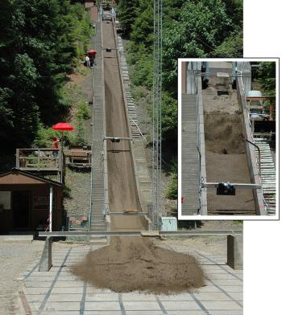
Learning Objective: Students will investigate landslides by creating a physical model of using different materials and testing the variables of slope, friction and gravity based on a flume that engineers have used to study landslides (see adjacent photo). They will also test materials with different amounts of water mixed in with them. After they have completed the investigation, they will be able to describe the different factors that affect the severity of a landslide- gravity, friction, different materials and how the changes in the amount of water affects the friction in landslides.

USGS Debris-flow flume near Blue River, Oregon is used to conduct debris flows and landslide experiments. Flume is a reinforced concrete channel 95 m (310 ft long, 2 m (6.6 ft) wide, and 1.2 m (4 ft).

Investigative Phenomena: Landslides are affected by the different types of materials, the amount of water and the steepness of the slope.

Guiding Question: How does the type of soil, the amount of water and the steepness of the slope effect landslides?

Lesson Implementation Timeframe: 3 to 4 (50-60 minute) class periods.
One class period should be dedicated for the students planning the investigation (with some guidance). See the lesson narrative below about this.

Classroom Resources and Materials:
- Landslide Lesson 2 PowerPoint
- Student Handout: L2 H1 Landscape Investigation Beta

Investigation Materials:

For Each Group:
- Clear tape
- Scissors
- 2 small paper cups; one for water, one for test material

Whole Class:
- 2 ft (.6 m) section of plastic downspout (available at hardware stores; ~$5)
- or you can use large pvc pipe cut in half (4” wide, 10ft. long)
- 1 small bag of sand
- 1 small bag of gravel
- 1 small bag of volcanic (lava) potting rock (available at garden and landscaping stores)
- 1 small bag of pottery clay (pottery clay would be best)
- Plastic bins to hold and store the earth materials (separately)
- 1 large, shallow, plastic waterproof tub (8-in x 14-in x 30-in or 20-cm x 36-cm x 76-cm, clear plastic is better but not necessary
- Plastic scoop (optional, or use small paper cup)
- Duct tape
- Scissors (to cut downspout plastic)
- Ruler (or tape measure)

Procedures

Engage

- Display slide 1. Welcome students. Introduce the lesson by revisiting some of the student generated questions from the previous lesson that related to the guiding question, “How can people prepare for the effects of the changing landscape on property?” Highlight a student question related to investigating the effects of landslides or add the investigative question, “What are factors (slope and type of soil) that effect landslides?”

Explore

- Display slide 2. Ask students to come up with a plan on how to study landslides by asking them, “How might you investigate the factors that affect landslides?”

Ask students to brainstorm different ideas (factors) that might affect landslides. Accept all student answers. The possible variables that students might test in their investigation include different types of soil (pebbles, clay, sand, or sand), slope (steepness) or amount of water. Encourage students to consider how they might build something to test their factors (variables) that can be raised at different heights to change the angle of the slope. Identifying the materials that are available to use for the student’s experimental design will help encourage students to think about how they will conduct their investigation. Show students the plastic downspout and ask, “How might you use the plastic downspout in your experiment to test a landslide? (Represents the slope) What are your testing for if you change the angle of the plastic downspout? (Steepness of the slope)”

- Display slide 3. Explain to the students that geologists and physical scientists use a debris flow flume to study how different materials, steepness, and amount of water effect the area below a landslide. For more information about a debris flow flume: https://volcanoes.usgs.gov/vhp/lahar_modeling.html

- Display Slide 4. Distribute Lesson 2, Handout 1 “Landslide Investigation” to each student. Assign students to groups of 4 and ask each of them to discuss the following questions:

- What are you investigating? Identify one factor (variable) that you want to investigate. Student should investigate only one variable at a time.
- How will you conduct your investigation? Discuss what a good experimental design might look like.
- What data will you collect and how will you display it?

Have the students record their discussion in the space provided on Lesson 2, Handout 1 “Landslide Investigation”. Ask a few select groups to share their answers to each of the questions for their investigation with the entire class.

- What are you investigating? Encourage students to consider using the different earth materials (sand, soil, clay, pebbles), different amounts of water, and raising their model “flume” to different heights.

- How will you conduct your investigation? Students will use a plastic downspout or PVC pipe as their flume. They can raise their flume to different heights. Students can select from the different materials including sand, soil, clay or pebbles and use varying amounts of water.

- What data will you collect and how will you display it? Suggest that the data they collect should be the height of their flume, the materials they used (water and earth materials combination), and the amount of damage that occurred (how far the debris travels at the bottom of the flume). Students might want to test the speed of the landslide, but this will be more difficult to quantitatively measure without more specialized tools.

- Display slide 5. Allow students to design, test, and re-test their debris-flow flume experiment. Share with students the data table in the slide is just an example of how they might collect and display their data. After collecting their data, ask students to analyze their data by making a claim. Provide students with a sample sentence frame to assist them in writing their claim. A sample sentence frame might say, “My claim is that ________ (factor) increases the amount of force to the area below the landslide compared to _______ (factor) because in trial #1 and #2 there was ________ than in trail #1 and #2 for the other factor.

Explain

- Display slide 6. If several computers with internet are available, individual students or groups can compare their results with similar experiments conducted by the USGS. As a whole class, show a sample of videos taken by the USGS of debris-flow flume experiments to explain and support the student results:

- Heights of flume: 2012_06_13 Dam-breach experiment at foot of flume: water impounded by 1-m-high dam or 2012_06_21 Dam-breach experiment at foot of flume: water impounded by 0/58-m-high
- Types of materials: 9-25-1992 Debris flow, wet sand & gravel or 2001-9-13 “Debris flow, sand, gravel & loam on rough bed”.
- Amount of water: 2014_07_31 Landslide initiation, loose 25% loam, surface sprinkling only or 2017_05_16 Landslide initiation, loose 25% loam, surface sprinkling followed by ground water

*You must have software that can play mp4 files.

Although students will not have quantitative data, they can observe in the USGS experiments how the data collected is similar or different from their own experiment. Ask the students the following questions after reviewing the USGS experiments:

- How was the USGS experiment similar to your experiment? The USGS experiment was similar to the student experiment. One different is the scale of the experiment. The USGS flume was larger and they used more materials to conduct the experiment.

- Did the USGS experiment support your claim with similar evidence? The USGS experiment show how different factors (variables) were tested and students can make similar observations.

Elaborate

- Display slide 7. Ask students to review their concept sketch they created in the previous lesson. Students have explored how different factors (variables) effect landslides. These factors are important characteristics of landslides in general. Tell students to revise their concepts sketches by adding information from their investigation and observations from the USGS experiments. Remind them to include the following additional concepts in their model:

  - Typo of soil tested
  - Steepness of slope
  - Arrows showing direction of water

Evaluate

- Display slide 8. After students have revised their models, ask them to leave them on their desks and tell them to circulate around the room making observations of each model. This activity is called a gallery walk. To encourage positive feedback, ask students to write a nice comment on a sticky note and leave it at a model for at least three different students. Tell students to only leave a sticky note with a comment if a student has not received one already so that all students will receive positive feedback. Encourage students to use the following sentence starter, “I like your model because…..”.

- Display slide 9. Ask students to answer the following question, “How did the data you collected from the experiment help you think about the guiding question, “How can people prepare for the effects of the changing landscape on property?” Students should cite that the experimental data helped them identify how different variables might effect landslides. The type of materials in the earth, steepness of slope, and amount of water are all factors to consider in designing an engineering solution to minimizing the effects of changing landscapes on property while still protecting the environment. Students will need to learn more about what engineering solutions to minimize the effects of the changing landscapes in the next lesson.
Lesson 3 – Landslide Preparedness

Learning Objective: Students will be able to analyze and interpret maps of different areas and look for different types of landslides and how susceptible they are to landslides. Students will design a communication strategy like a public service announcement or infographic to increase landslide awareness and preparedness.

Investigative Phenomena: Different areas and communities are more susceptible to landslides.

Guiding Question: How can you prepare for landslides?

Lesson Implementation Timeframe: 2 (50-60 minute) class periods

Classroom Resources and Materials:
- Landslide Lesson 3 PowerPoint
- Student Handout: L3 H1 Landslide Map Explanation Beta
- Student Handout: L3 H2 Landslide Types and Processes Beta
- Student Handout: L3 H3 FEMA Landslide Beta
- Student Handout: L3 H4 DOC Landslide Fact Sheet Beta
- Computers for each student

Procedures:

Engage

- Display slide 1. Welcome students and review lessons 1 and 2 by asking, “What have we learned so far about landslides?” Acknowledge all answers and share with students that in this last lesson they will be responsible for creating a communication strategy to increase awareness about landslides.

- Display slide 2. Show the video “When Nature Strikes – Landslides” (https://www.youtube.com/watch?v=dj44dpr8oHs). Ask students, “Why is studying and creating models of landslides important to humans?” Studying landslides are important to understand their causes and effects to humans. Creating models of landslides will help us predict where and under what conditions they might exist.

- Display slide 3. Remind students that they investigated different factors (variables) in lesson 2 that effect landslides. Ask students to think about where these conditions (factors) might exist in their community and can they predict where landslides might exist?

Explore

- Display slide 4. Have the students get out their laptops or devices and have them go to the California Department of Conservation Landslide Inventory Map: https://maps.conservation.ca.gov/cgs/lsi/. If computers are not available for individual students or groups of students, explore the site as a class.

Give them some time to explore the map and the different layers. Make sure they understand the map legend from the handout and have them use this as they are looking at the map. After 5 minutes of exploring, have them find their city or neighborhood on the map (this can be typed in or they can scroll and zoom to their area).

- Display slide 5. Ask students to locate where the Mud Creek Landslide occurred (Search: 73275 CA-1, Big Sur, CA 93920). Give each student a copy of Handout 1 “Landslide Map Explanation” handout and support the students with how to utilize the map to find out more information about landslides by explaining the different symbols using slides 6 – 7.

Explain

- Display slide 6. Pass out Handout 2 “Landslide Types and Processes” from lesson 3. Explain the different symbols from the Landslide by reviewing the images on page 3 of L3 Handout 2 and matching them with the symbols in Handout 1. See below for the correct alignment.
Landslide Map Explanation | USGS Landslide Types and Processes Image (Letter ID)
Debris Flow | Debris Flow (F)
Debris Slide or Soil Slide | Translational Slide (B)
Earth Flow | Earthflow (H)
Rock Fall, and Soil Fall; Rock Topple and Soil Topple | Rockfall (D) and Topple (E)
Rock Slide | Similar to a rock fall, but on a gentler slopes (A and B)
Rock Spread | Lateral spread (J)
Debris Fan | Similar to a debris flow (F) but with a soil spreading out more (Alluvial fan)

- Display slide 7. Define the four landslide ages by using the descriptions on the right-hand side of slide 7. In Handout 1, describe the symbols for the interpretation confidence: definite, probable or questionable.

- Display slide 8. Revisit the Mud Creek Landslide and identify the type and age of the landslide using the symbols. Select the area that indicates the most recent landscape activity. A text box will appear and identify the type of landslide (Rock slide). Identify the age of the landslide by the color (Active/Historic) and the interpretation confidence (Definite).

- Display slide 9. Ask students to identify the nearest landslide threat to their community by using the search feature and adding the school zip code to the box. Students may need to zoom in or out to find a quadrant with landslide information. Ask students to identify the landslide type, activity, and confidence using the Landslide Inventory map and symbols.

Elaborate

- Display slide 10. Share with students that they will use their knowledge about landslides to design a communication strategy like a public service announcement (PSA) or infographic to increase landslide awareness and preparedness. In their PSA, students should include the following components:
- Definition of a Landslide
- Landslide Causes
- Types of Landslide
- Identifying Landslide Location
- Landslide Preparedness

Show students some examples of communication strategies by sharing with them the FEMA infographic (L3 H3 FEMA Landslide Beta) and an example of a video.

FEMA Infographic

Example of safety videos by high school students:
- https://www.youtube.com/watch?v=bX7z102Kq-Q
- https://www.youtube.com/watch?v=vcu77729sso

*Powtoon: https://www.powtoon.com/index/ This is one example of a resource for students if they want to make their own video.

Distribute the Department of Conservation Fact Sheet on Debris flows, mudlfows, mudslides, and landslides by the California Geological Survey (L3 H3 DOC Landslide Fact Sheet Beta). Tell students that they can use the fact sheet as a resource to help them with their communication strategy.

Evaluate

- Display slide 11. Allow student to showcase their public service announcements by presenting their PSA to the class.

